**Project Design Phase-II**

**Data Flow Diagram & User Stories**

|  |  |
| --- | --- |
| Date | 03 November 2022 |
| Team ID | PNT2022TMID33757 |
| Project Name | Child safety gadget monitoring and notifying |
| Maximum Marks | 4 Marks |

**Data Flow Diagrams:**

A Data Flow Diagram (DFD) is a traditional visual representation of the information flows within a system. A neat and clear DFD can depict the right amount of the system requirement graphically. It shows how data enters and leaves the system, what changes the information, and where data is stored.

Example: DFD Level 0 (Industry Standard)

**Flow diagram:**

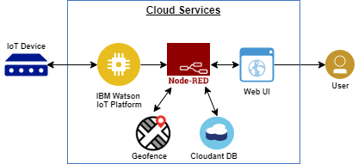

Getting notification from the gadget to the parents

Entering the username and password

Login

Authenticating the user by verifying the cconfirmation

Entering the radius of the location

**User Stories**

Use the below template to list all the user stories for the product.

| **User Type** | **Functional Requirement (Epic)** | **User Story Number** | **User Story / Task** | **Acceptance criteria** | **Priority** | **Release** |
| --- | --- | --- | --- | --- | --- | --- |
| parents | Registering into the device | USN-1 | As a user, I can register for the application by entering my email, password, and confirming my password. | I can access my account / dashboard | High | Sprint-1 |
|  |  | USN-2 | As a user, I will receive confirmation email.to enrich security purpose | I can receive confirmation email & click confirm | High | Sprint-1 |
|  |  | USN-3 | As a user, I can view the notification from the children gadget | Accepting the notification from the mobile | high | Sprint-2 |
|  |  |  |  |  |  |  |
|  | Login | USN-5 | As a user, I can log into the application by entering email & password and entering to particular radius distance to an extent to which child can move |  | High | Sprint-1 |
|  | Dashboard |  |  |  |  |  |
| Children | Wearing the gadget | USN_1 | Calculate the distance with the sensor present and give the notification to the system |  | high | Sprint -1 |
|  |  |  |  |  |  |  |
|  |  |  |  |  |  |  |
|  |  |  |  |  |  |  |
|  |  |  |  |  |  |  |
|  |  |  |  |  |  |  |